SkillsCertify.org - Online Skill Certification Platform
Shyam is a graduate who dreams of building his career in the Human Resources domain. However, due to limited job opportunities in the market, Shyam accepted a job as a Process Executive in a company. Although he is working hard, the job is not related to his interest in HR. After a few months, Shyam becomes dissatisfied and starts searching again for HR opportunities.
Because of this situation, the company that hired Shyam loses the time, effort, and money spent on training him. At the same time, Shyam also loses valuable time in his career because the job he accepted did not help him grow in the field he wanted. This type of problem is happening in many organizations where candidates accept any available job instead of roles aligned with their interests and skills. As a result, companies experience frequent employee turnover, and candidates struggle to build the right career path.
After observing this issue, the management team at APT IT Solutions decided to find a solution. Mr. Ram, the CEO, discussed this with Mr. Ravi (Financial Head) and Ms. Latha (Project Coordinator). To solve this problem, APT IT Solutions decided to develop SkillsCertify.org — an online platform where candidates can select their desired domain and take role-based certification exams designed by SMEs. Partner companies can access the certified candidate database to hire candidates who are skilled and genuinely interested in relevant roles.
APT IT Solutions is developing this platform with a budget of Rs. 1.5 Crores and a duration of 18 months. Mr. Raju is the Delivery Head and Mr. Krishna is the Project Manager.

Your Project Team:

Role | Name
Project Manager | Mr. Krishna
Senior Java Developer | Ms. Juli
Java Developers | Mr. Chris, Mr. William, Mr. David, Mr. John
Network Administrator | Mr. Daniel
Database Administrator | Mr. Steve
Testers | Mr. Peter, Ms. James
Business Analyst | You

To gather business requirements from the client, you met Mr. Ram (CEO) at APT IT Solutions. Mr. Ram (CEO) stated that he expects the platform to have a login/registration system for all users (Candidates, SMEs, and Partner Companies), a domain selection feature, a certification exam module, a candidate profile and dashboard, and a company portal to search for certified candidates.
Key stakeholder inputs: Shyam (Candidate) — candidates should browse exams by domain without logging in and only log in when registering for an exam. SME representatives — SMEs need a dedicated portal to create, edit, and publish exams. HR Manager from Tech Mind Solutions — partner companies need to search the certified candidate database by domain, skill level, and score, and receive notifications when new candidates are certified.
Business Requirements Identified (Sample): BR001 – Candidates should be able to browse and search for available certification exams by domain on SkillsCertify.org. BR002 – SMEs should be able to create, upload, and manage role-based certification exams on the platform.
Functional & Non-Functional Requirements (Sample):
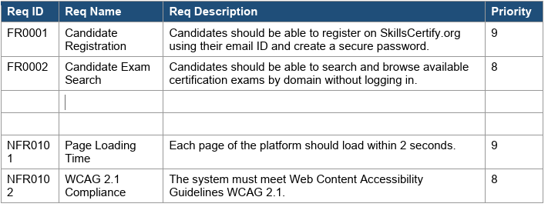
Once the requirements are finalized, as a BA you need to act as a liaison between the client and the project team — gathering requirements correctly from the client and delivering them to the development team in a way they understand. This includes creating UML diagrams and screen mock-ups.

Question 1 – Functional Requirements – 15 Marks
Identify a minimum of 20 Functional Requirements and NonFunctional Requirements for the SkillsCertify.org platform. Present in the format: Req ID | Req Name | Req Description | Priority

Answer 1:
(Functional Requirements):- It defines the specific behaviour, function or operations of a system. It describe what the system would do, outlining the necessary tasks, actions or activities it must perform to achieve its objectives.

Req ID | Req Name | Req Description | Priority
FR001 | Candidate Registration | Candidates should be able to register with personal details. | High
FR002 | Candidate Login | Secure login for candidates. | High
FR003 | Browse Exams | Candidates can browse exams by domain without login. | High
FR004 | Exam Registration | Candidates can register for chosen exams. | High
FR005 | Candidate Dashboard | Personalized dashboard showing exam history, scores, certificates. | High
FR006 | SME Registration | SMEs can register and create accounts. | High
FR007 | SME Exam Creation | SMEs can create, edit, and publish exams. | High
FR008 | Exam Management | SMEs can manage exam versions and updates. | Medium
FR009 | Partner Company Registration | Companies can register and access candidate database. | High
FR010 | Candidate Search | Companies can search certified candidates by domain, skill level, score. | High
FR011 | Notifications | Companies receive notifications when new candidates are certified. | Medium
FR012 | Certificate Generation | System generates certificates after successful exam completion. | High
FR013 | Profile Management | Users can update their profile details. | Medium
FR014 | Role-Based Access | Different portals for Candidates, SMEs, and Companies. | High
FR015 | Exam Attempt | Candidates can attempt exams online with timer and submission. | High
FR016 | Result Processing | Automated evaluation and score generation. | High
FR017 | Secure Data Storage | Candidate and exam data stored securely. | High
FR018 | Reporting | Admin can generate reports on usage, exams and certifications. | Medium
FR019 | Multi-Device Access | Platform accessible via desktop and mobile. | Medium
FR020 | Help & support | Integrated helpdesk for queries. | Medium
Non Functional Requirements:- It will describe the qualities and attributes of the system. It focusing on how the system performs rather than specific behaviours or functions.
Req ID | Req Name | Req Description | Priority
NFR001 | Performance | System should support 10,000 concurrent users. | High
NFR002 | Security | Data encryption for login and exam data. | High
NFR003 | Availability | 99.9% uptime guarantee. | High
NFR004 | Scalability | Should scale to support growing user base. | High
NFR005 | Usability | Userfriendly UI for all user types. | Medium
NFR006 | Maintainability | Easy to update and maintain. | Medium
NFR007 | Compatibility | Works across browsers and devices. | Medium
NFR008 | Backup & Recovery | Daily backups and disaster recovery plan. | High
NFR009 | Response Time | Pages should load within 3 seconds. | High
NFR010 | Compliance | Adherence to government regulations. | High

Question 2 – Minimum 5 Page Designs – 15 Marks
Create wireframes and prototypes for a minimum of 5 key pages of the SkillsCertify.org platform.

Answer 2:
Wireframe: Wireframe is like a Blueprint. It is like a sketch diagrams. It helps stakeholders to explain the
requirement efficiently.
It is done by Balsamiq tool. Balsamiq tool is used to create wireframes and mockups.
Mockups: It is advanced stage of wireframes. Mockups design the improved version of the wireframe. It
shows how the future system will look like. We can also navigate one page to another page by using
mockups.
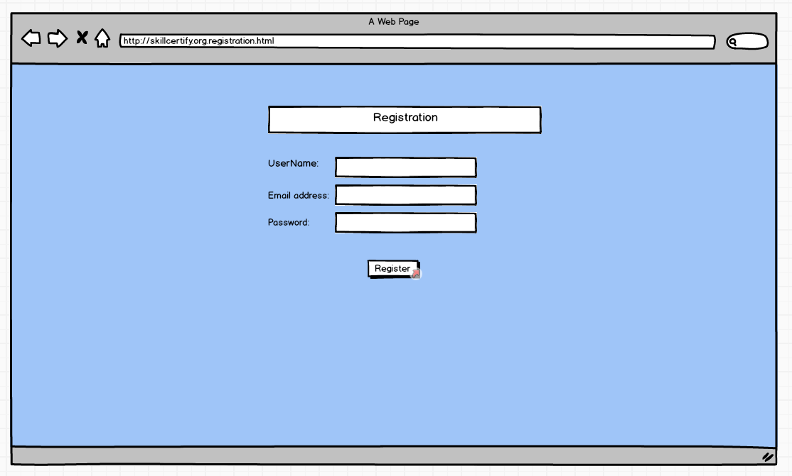
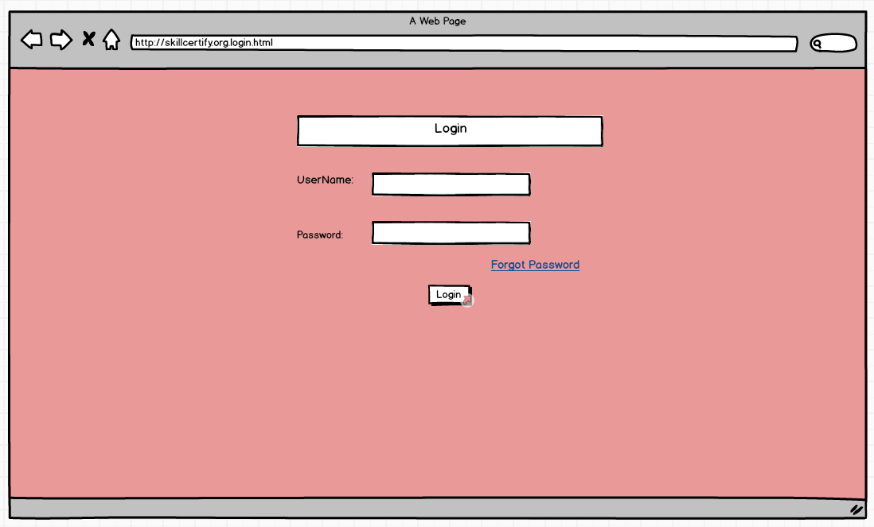

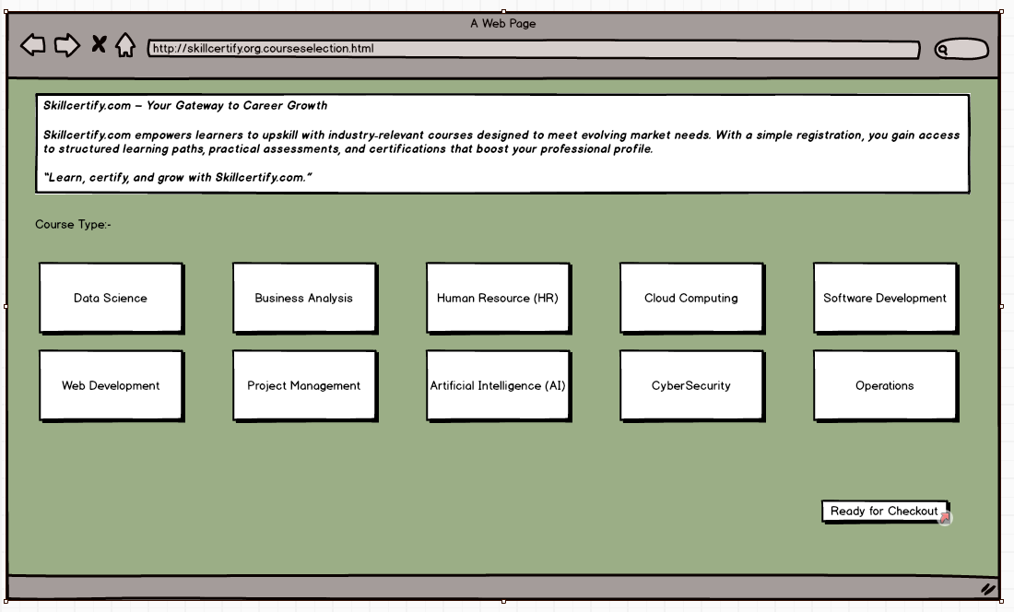
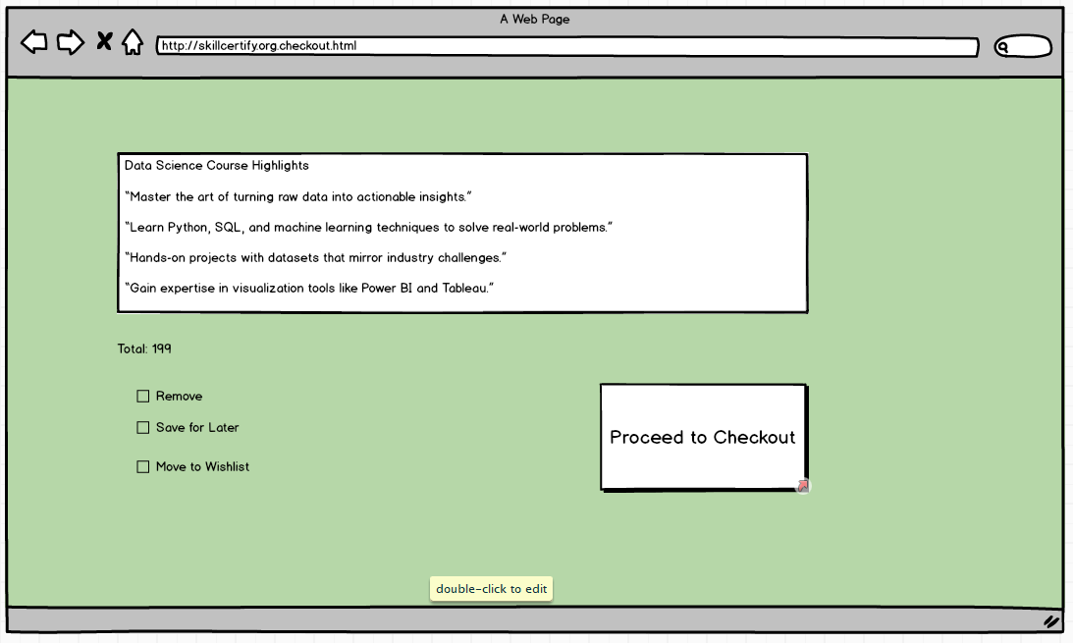

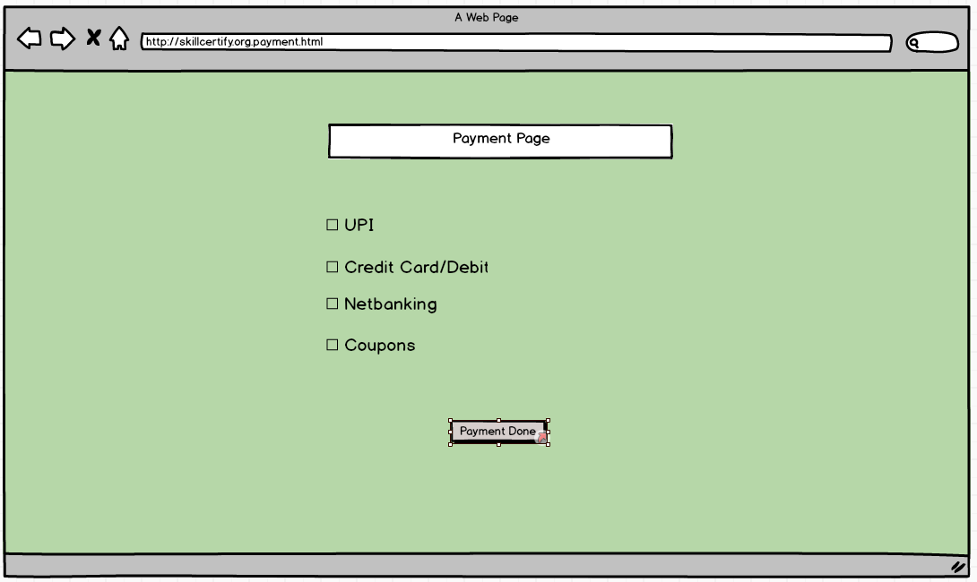
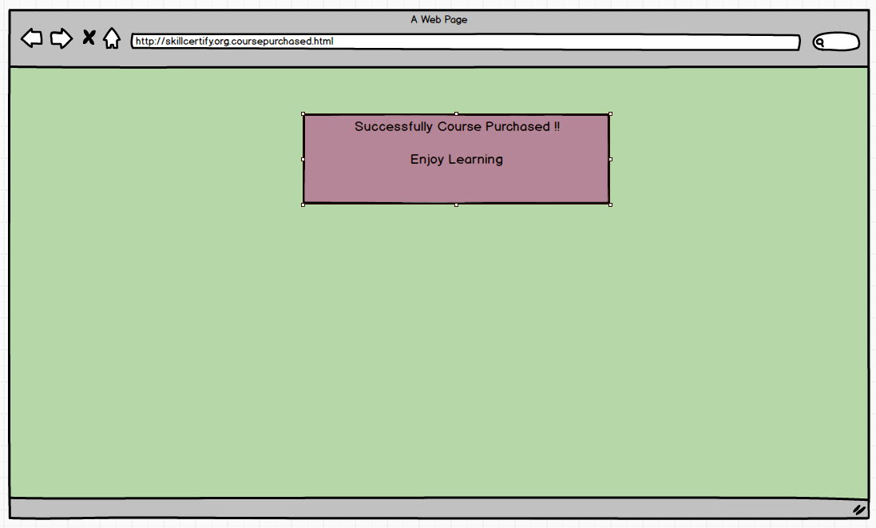

Prototyping: It is done by Axure RP tool. We are using it to create web and mobile application. . It is advanced than mockups.

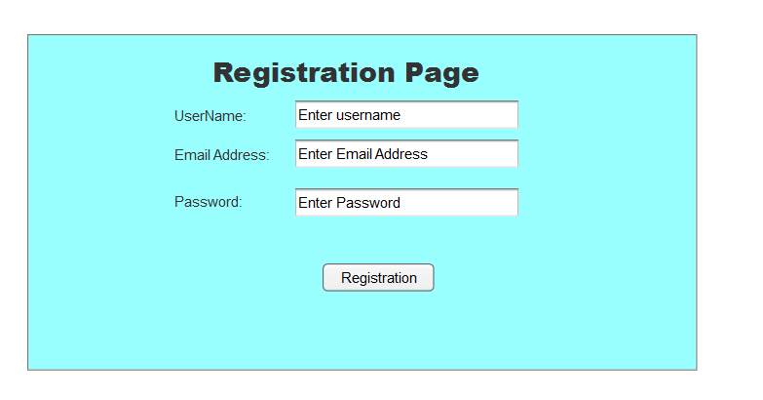
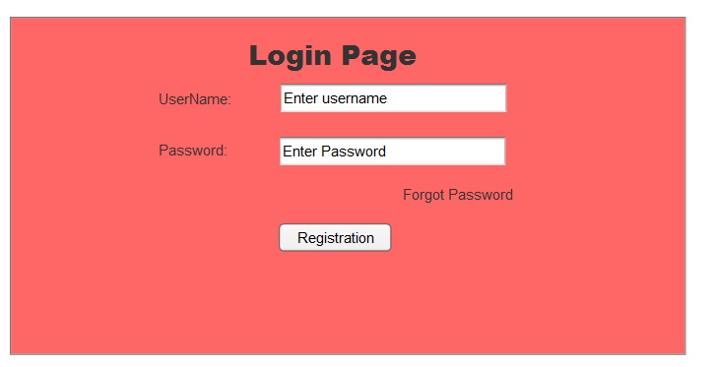

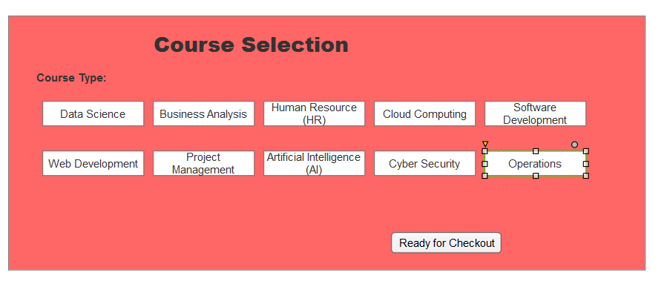
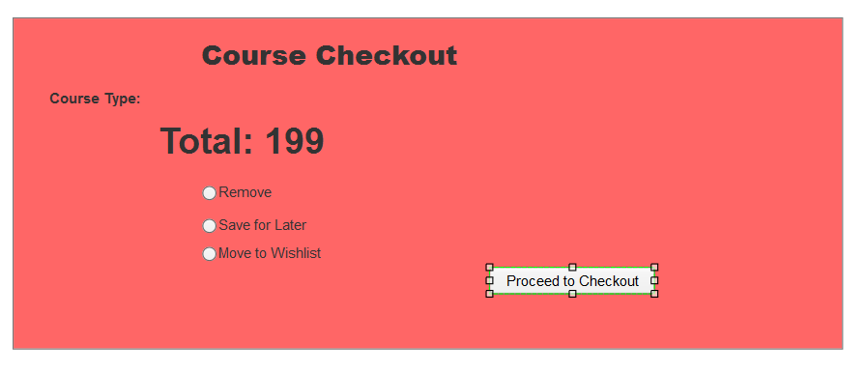
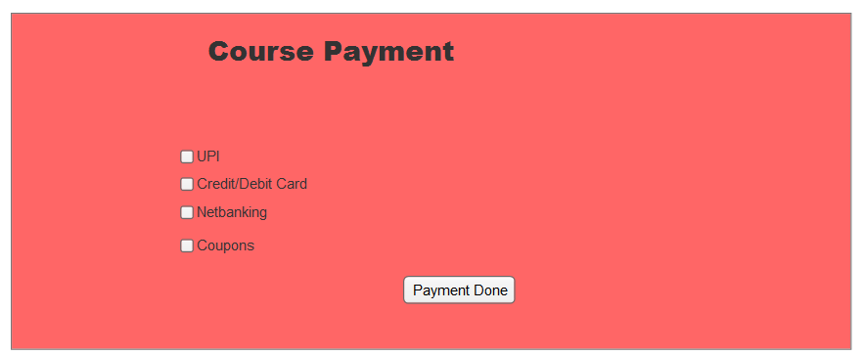

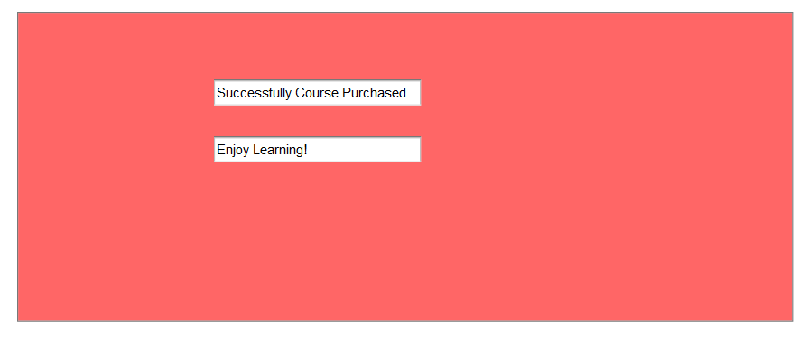

Question 3 – Tools (Visio, Balsamiq) – 15 Mark
Make a note of the BA tools you are using for the SkillsCertify.org project. For each tool, explain its purpose in the context of SkillsCertify.org and why it is suitable for the project.

Answer 3:
MS Visio – It is a diagrammatic and vector graphics application tool used to create diagram, flowcharts and other visual representation of complex information. It is suitable because it provides professional diagramming features. We use MS Visio for creating UML diagrams (i.e. Use Case Diagram, Activity Diagram, sequence Diagram).
Balsamiq – It is rapid wireframing tool used to create mockups and prototyping of user perspective. It is easy drag-and-drop interface for quick mockups. It’s useful for showing how a website or app might look from the user’s point of view.
Axure – It is more advanced prototyping tool used to create high fidelity, interactive wireframes and prototypes for web and mobile applications. It is used for tracking requirements systematically and testing how users will interact with the design

Question 4 – RTM – 6 Marks
A BA's key responsibility is to keep track of requirements and ensure no requirement is missed throughout the SDLC. Mr. Ram(CEO of APT IT Solutions) and Shyam (representing the candidate community) have approached you regarding the current status of the project. How will you tackle this situation? Prepare the Requirements Traceability Matrix (RTM) for SkillsCertify.org mapping each requirement through: Design → D1 → T1 → ... → T4 → UAT. Use the sample RTM structure below as a starting format and complete it with your full requirements list:

Answer 4:-
RTM: RTM stands for Requirement Traceability Matrix. It is a document/File which used to track all the requirements throughout the project lifecycle. It also ensures that they are met during the development and testing phase. No requirements are overlooked.

Req ID | Req Name | Req Description | Design | Development | Unit Testing | System Testing | UAT Testing
FR001 | Candidate Registration | Candidates should be able to register with personal details. | Completed | Completed | Completed | Completed | Completed
FR002 | Candidate Login | Secure login for candidates. | Completed | Completed | Completed | Completed | Completed
FR003 | Browse Exams | Candidates can browse exams by domain without login. | Completed | Completed | Completed | Completed | Completed
FR006 | SME Registration | SMEs can register and create accounts. | Completed | Completed | Completed | Completed | Completed
FR007 | SME Exam Creation | SMEs can create, edit, and publish exams. | Completed | Completed | Completed | Completed | Completed
FR010 | Candidate Search | Companies can search certified candidates by domain, skill level, score. | Completed | Completed | Completed | Completed | Completed
FR018 | Reporting | Admin can generate reports on usage, exams, and certifications. | Completed | Completed | Completed | Completed | Completed

Question 5 – 10 Test Case Documents – 10 Marks
Prepare 10 Test Case Documents for the SkillsCertify.org platform.
For each test case include: Test Case ID, Test Scenario, Preconditions, Test Steps, Expected Result, Actual Result, Status.

Answer 5:
A test case document is a detailed document used by testers to ensure that a software application or system working as expected. It also keep record how each and every functionality will be tested. It also provides detailed steps
Test Case ID | Scenario | Preconditions | Steps | Expected Result | Actual Result | Status
TC01 | Candidate Registration | Candidate not registered | Fill form → Submit | Account created | As expected | Pass
TC02 | Candidate Login | Candidate registered | Enter credentials → Login | Dashboard opens | As expected | Pass
TC03 | Browse Exams | Exams available | Click Browse Exams | List displayed | As expected | Pass
TC04 | Exam Registration | Candidate logged in | Select exam → Register | Registration confirmed | As expected | Pass
TC05 | Exam Attempt | Candidate registered | Start exam → Submit | Result generated | As expected | Pass
TC06 | SME Exam Creation | SME logged in | Create exam → Publish | Exam visible to candidates | As expected | Pass
TC07 | Candidate Search | Company logged in | Search by domain | Candidate list displayed | As expected | Pass
TC08 | Certificate Generation | Candidate passed exam | Generate certificate | Certificate issued | As expected | Pass
TC09 | Notifications | New candidate certified | System triggers notification | Company notified | As expected | Pass
TC10 | Profile Update | Candidate logged in | Edit profile → Save | Profile updated | As expected | Pass

Question 6 – DB Design – 8 Marks
After the requirements are thoroughly explained to the entire project team by the BA, the Database Architects have decided to do the database design and represent the in-flow and out-flow of data for SkillsCertify.org.
Draw the Database Schema and ER Diagram for SkillsCertify.org

Answer 6-
DB Design:- DB stands for database. DB schema is a layout of the database structure. It includes tables, fields, relationships, constraints and other characteristics.
Table Name | Key Fields
Candidate | UserID (PK), Name, Email, Password, Role (Candidate)
Courses | ExamID (PK), CourseID (PK), Title, Description, CreatedBy (FK)
Exams | ExamID (PK), CourseID (FK), Title, Duration
Questions | QuestionID (PK), ExamID (FK), QuestionText, Type
Certificates | CertificateID (PK), CandidateID (FK), ExamID (FK), IssueDate
Subject Matter Expert | UserID (PK), Course Type, Difficulty Level, Status
HR Manager | UserID (PK), Company Name, Required Skills, Search Candidates
Notifications | NotificationID (PK), UserID (FK), Message, DateSent

ER Diagram:- ER stands for entity relationship Diagram. It is a visual representation of the relationships between entities in a database. It creates relationship between tables (entities), attributes (Properties/field).
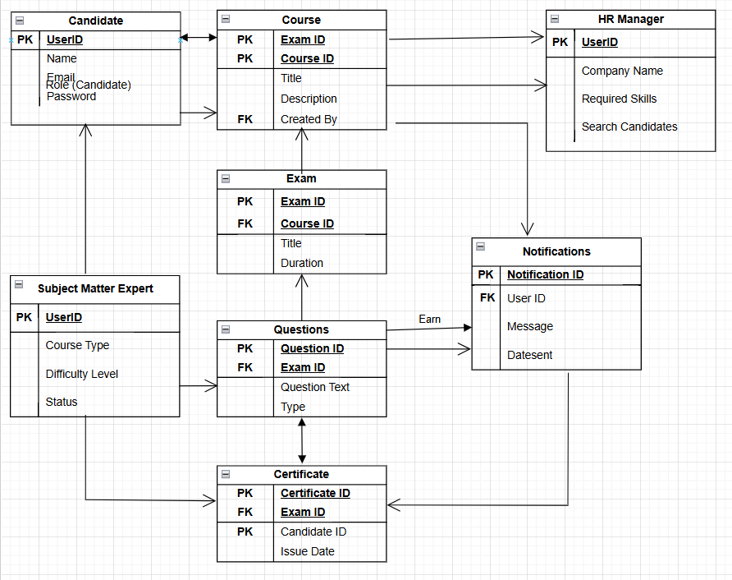

Question 7 – Data Flow Diagram – 3 Marks
What is a Data Flow Diagram (DFD)? Draw a Data Flow Diagram to represent the in-flow and out-flow of data when a Candidate registers for and takes a Certification Exam on SkillsCertify.org.

Answer 7:-
Data Flow Diagram:- It is a graphical representation of the data flow within a system. It visually shows how the data moves from one process to another, how data is stored and where it ends.
It also helps to understand the flow of data within a system, identify potential impediments or inefficiencies and communicate system requirements to stakeholder.
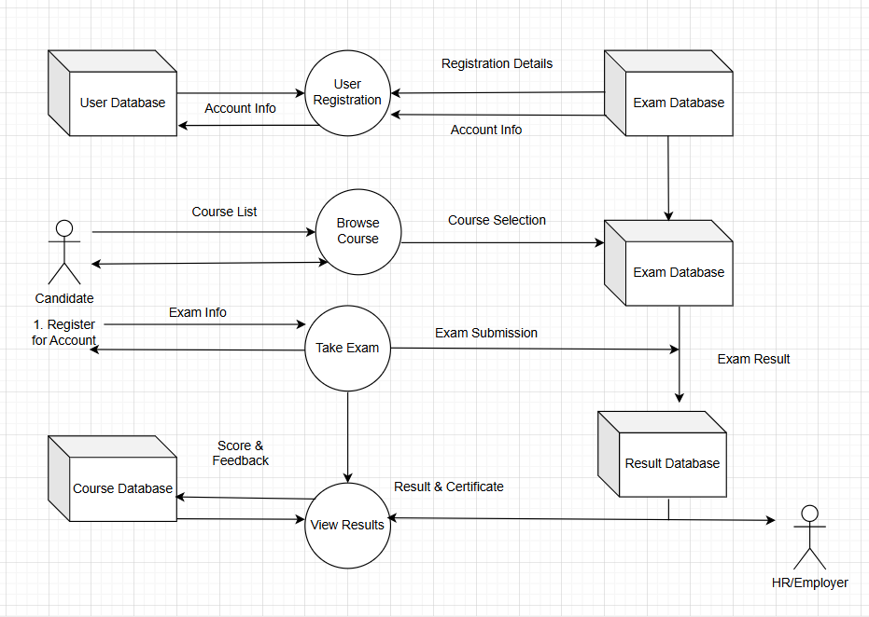

Question 8 – Change Request – 10 Marks
Due to a new Government regulation, all online certification platforms are now required to issue digitally signed certificates with a QR code that can be verified by third parties. This was not part of the original requirements for SkillsCertify.org. How do you handle this Change Request in the project?

Answer 8:-
Change Request: A change request is a formal proposal to alter a system, product or project. We are adding new features (certificate should have digital sign along with QR code) to an existing feature (This was not original requirement). For this, we adding this feature then addition would be known as Change Request.
For this addition, we have to follow below points:-
a) Firstly, we should know the scope of change request and document these changes (sign off)
b) We will do the Impact Analysis (Most Important)- project scope, schedule, budget, resources and risks
c) Focus on prioritizing the change request (as per urgency),
d) Take approval from Project Sponsor, CCP (Change Control Port)
e) We should communicate the change request and its potential impact to all relevant stakeholders along with project team.

Question 9 – Change Request Vs Enhancement – 5 Marks
As the SkillsCertify.org project is in progress, the HR Managers from Tech Mind Solutions and Zillion Technology have contacted you. They want the platform to also allow Partner Companies to post job openings directly on SkillsCertify.org, so that certified candidates can apply for jobs through the platform itself. They also want to introduce an AI-based candidate recommendation engine that automatically suggests certified candidates to companies based on their hiring history. As a BA, what will be your response? Is this a Change Request or an Enhancement? Justify your answer clearly explaining the difference between a Change Request and an Enhancement, and classify this request accordingly

Answer 9:-
There is a thin line difference between Change Request and Enhancement.
Change Request = Mandatory compliance/regulation changes.
Enhancement = Additional features improving usability.
Change Request
A Change Request happens when something must be changed in the project scope — usually because of external factors like regulations, compliance, or client demands. It alters the original agreed requirements. For change request, we always do Impact Analysis. We always see the project scope, budget and resources and risk (if any or not). Take approval from CCP.
Example: Government mandates that all online certificates must have a QR code. This wasn’t in the original plan, but now it’s compulsory, so the project scope must change.
Enhancement
An Enhancement is an extra/new feature or improvement added to make the product better, more useful, or more attractive. It’s not mandatory — it’s usually requested by stakeholders to add value. For adding this enhancement, first we need to work on feasibility study and after that impact analysis of the new enhancement. Also, we should consider the benefits of this enhancement, risks, cost associated with enhancement.
Example: Adding an AI-based recommendation engine or allowing companies to post jobs directly on the platform. These features improve the system but aren’t required to meet the original scope.

Question 10 – Estimations – 6 Marks
Come up with effort estimations for the SkillsCertify.org project. How many Manhours are required to complete this project within the 18-month timeline with a budget of Rs. 1.5 Crores?

Answer 10:-
To understand the Project Estimations, we should first understand the project size. Hours are the required effort of the resources to complete a project. There are 3 types of projects:-
- Small: Upto 500 hours
- Medium: Upto 1000 hours
- Large: Upto 1500 hours
The duration of this project is 18 Months (540 Days) and Budget is Rs. 1.5 Crores.
Assuming 10 team members × 8 hours/day × 540 days = 43,200 hours (Allocate across BA, PM, Developers, Testers, DBA, Network Admin). As per my understanding, this project should consider under Large Project Type.

Question 11 – UAT – 6 Marks
The SkillsCertify.org project has finally completed all stages: design, development, and testing. Now, as a BA, it is your role to contact the client (Mr. Ram(CEO of APT IT Solutions) and the committee) for User Acceptance Testing (UAT) and to successfully complete it. How are you going to handle this situation? Once UAT is done, what will be the process to close the project?

Answer 11:-
Planning: Firstly we will make a plan. We will check that Business users are available or not for UAT. Blue Prints are made to implement UAT testing (test scenario) for every feature that needs to test and minimum standards for accepting the test case.
Designing: Test cases are designed to hide all the possibilities of software packages in a real-world environment.
UAT Tester: A Testing team consist of a end users that meet the criteria for implementing testing. They should know the test cases to run and understand the functionalities.
Bug Fixing: Whatever Bugs are found in the UAT Testing, the development team should work on them and make it software error free.
Sign Off: All fixing all the bugs, All the stakeholder concludes that Software is ready to GO LIVE and sign it off.

Question 12 – Project Closure Document – 6 Marks
Explain the Project Closure Document for the SkillsCertify.org project.

Answer 12:-
Project Closure Document: It is also known as Project Closure Report. It contains the outcomes, lesson learned and final details of the completed project.
It serves as a comprehensive record of the project accomplishments, challenges and overall performance, providing valuable insights for stakeholders and future projects.

Below points should include in Project Closure.
- Project Summary/Overview
  - Scope
  - Objectives
  - Deliverables
- Project Achievements
- Lesson Learned
- Lessons Learned
- Resource Release.
- Closure Approval by stakeholders.

